 | https://www.nspcc.org.uk/keeping-children-safe/support-for-parents/
 | https://www.familyhubsleicestershire.org.uk/parents-and-carers/parenting-support
 | https://www.ncdv.org.uk/
 | https://www.leicspart.nhs.uk/service/diana-childrens-community-service-child-and-family-support-service-cafss/
 | https://thesleepcharity.org.uk/
 | https://healthforunder5s.co.uk/
 | https://www.healthystart.nhs.uk/
 | https://www.leicspart.nhs.uk/service/healthytogether/
 | https://www.leicestershire.gov.uk/education-and-children/schools-colleges-and-academies/teen-health-11-19
 | https://www.nhs.uk/start-for-life/
 | https://home-startsouthleics.org.uk/
 | https://www.anxietyuk.org.uk/
 | https://www.sendiassleicestershire.org.uk/
 | https://www.mind.org.uk/
 | https://www.citizensadvice.org.uk/
 | https://www.turn2us.org.uk/
 | https://www.entitledto.co.uk/
 | https://www.actionforchildren.org.uk/how-we-can-help/get-parenting-support/
 | https://www.guysgift.co.uk/
 | https://winstonswish.org/
 | https://www.nhs.uk/every-mind-matters/
 | https://www.moneyhelper.org.uk/en?source=mas
 | https://resources.leicestershire.gov.uk/education-and-children/child-protection-and-safeguarding/early-help
 | https://www.familylives.org.uk/
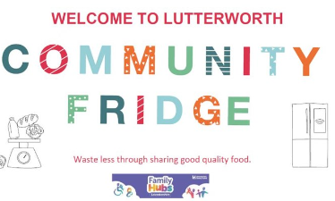 | https://www.neighbourly.com/project/65ccf8f7f832bc3cca54b7e6
 | https://www.familyhubsleicestershire.org.uk/find-family-hub/lutterworth-family-hub
 | https://www.leicspart.nhs.uk/services/help-support-resources/?v=12881
 | https://solihullapproachparenting.com/
 | https://www.oneplusone.org.uk/parents
 | https://www.familyhubsleicestershire.org.uk/sites/familyhubs/files/2024-11/carers-info-pack-2024_0.pdf

Leicestershire HAF Programme
https://www.leicestershire.gov.uk/education-and-children/social-care-and-supporting-families/holiday-activities-and-food-haf-programme#:~:text=Leicestershire%20Holidays%20Together%3A%20Holiday%20Activities,activities%20alongside%20a%20nutritious%20meal.



