
www.healthforkids.co.uk
Healthy Together Newsletter ISSUE 07
Welcome to your latest
Healthy Together newsletter
Hello and welcome to the seventh
edition of your newsletter for
parents/carers and school staff from
Healthy Together, and the second of
the 2024/25 academic year.
In this update, you can find out about
the free online parental courses
available to you, our animation to
support you in preparing your child for
secondary school and how to access
our new speech and language toolkits.
Digital health contact to launch for parents/carers of children in reception
Following the Easter holidays, parents/carers of children in reception will have access to a Digital Health Contact; an online
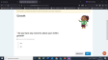
questionnaire that covers various topics linked to your child’s health and wellbeing and offers you support.
The contact covers a
variety of topics including:
Growth
Development
Speech and language
Toileting
Be sure to look out for communications from your child’s school in the coming weeks with information on how to access the Reception Digital Health Contact.
Access free online parenting courses
Leicestershire Partnership NHS Trust has partnered with Solihull Approach to offer free access to expertly designed online courses, which cover concerns that parents, carers, grandparents often face.
Courses include:
Understanding your child with additional needs
Understanding your child's feelings Understanding your child's mental health and wellbeing
Understanding your teenager's brain

Click here or
on the image
to access the
courses
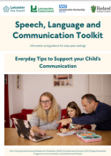
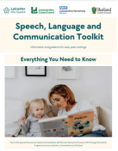
www.healthforkids.co.uk In the Spotlight
Parental speech and language toolkit
We have recently published a speech, language
and communication toolkit developed by Speech
and Language Therapists to help you support
your child’s communication at home
Whether you’re looking for quick tips or detailed
guidance, you’ll find practical advice, videos, and
resources tailored to your child’s needs
Click here to view the speech and language toolkit
Contact a school nurse by text message
Leicestershire Partnership NHS Trust runs a dedicated, confidential and secure text messaging service called ChatHealth for parents/carers of children aged 0-11 in Leicestershire and Rutland, which enables you to get professional health advice and support.
Text a Public Health Nurse (School Nurse) on: 07520 615 382

Contact a health professional via the Healthy Together Helpline
You can also call to speak to the
Helpline’s qualified health and
administrative professionals who offer
Supporting your child prepare for secondary school With families with children in Year
6 recently finding out about their child’s secondary school place for the next academic year, we wanted to remind you of our animation which offers advice and guidance for parents/carers in supporting your child as they prepare for this next step in their education.
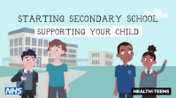Click here to watch our
easy to access, safe and free advice, support and signposting.
Helpline
starting secondary school animation
Call 0300 300 3001 Calls are answered from 9am – 4.30pm on weekdays, excluding bank holidays.
There’s also an animation that your child can watch too to help them feel prepared for their first day.

